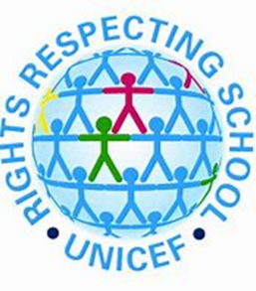
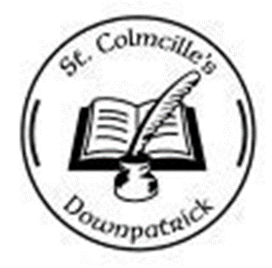
St Colmcille’s Primary School
Playground Charter!

We have a right to play, rest and meet and join in with other children! Art 31 & 15
We will play kindly and have fun.
We will welcome and include everyone.
Adults will ensure we have time and space to play.
They will provide equipment and teach us new games.


We have the right to be listened to! Art 12
We will speak kindly, honestly, and respectably.
We will listen when others speak to us.
We will share ideas of how we would like to play and relax.
We will put our rubbish into the correct recycling bins and tidy away our play equipment.
Adults will allow us to share our ideas and listen to what we have to say.
Adults will provide recycling bins and ensure our equipment is clean.

We have the right to be treated with respect and fairness! Art 2
We will treat people how we wish to be treated.
We will make sure that no one is left out.
Adults will ensure that all children have what they need to be able to take part in play and that games and equipment are accessible to everyone.
We have a right to be safe and be in a safe and clean environment! Art 19 & Art 24
We will play gently and kindly.
We will look out for each other and make safe choices and tell and adult if someone is hurt.
Adults will ensure all our equipment is safe and will bring us to First Aid if we are hurt. Adults will help us made good choices and be kind to each other.

